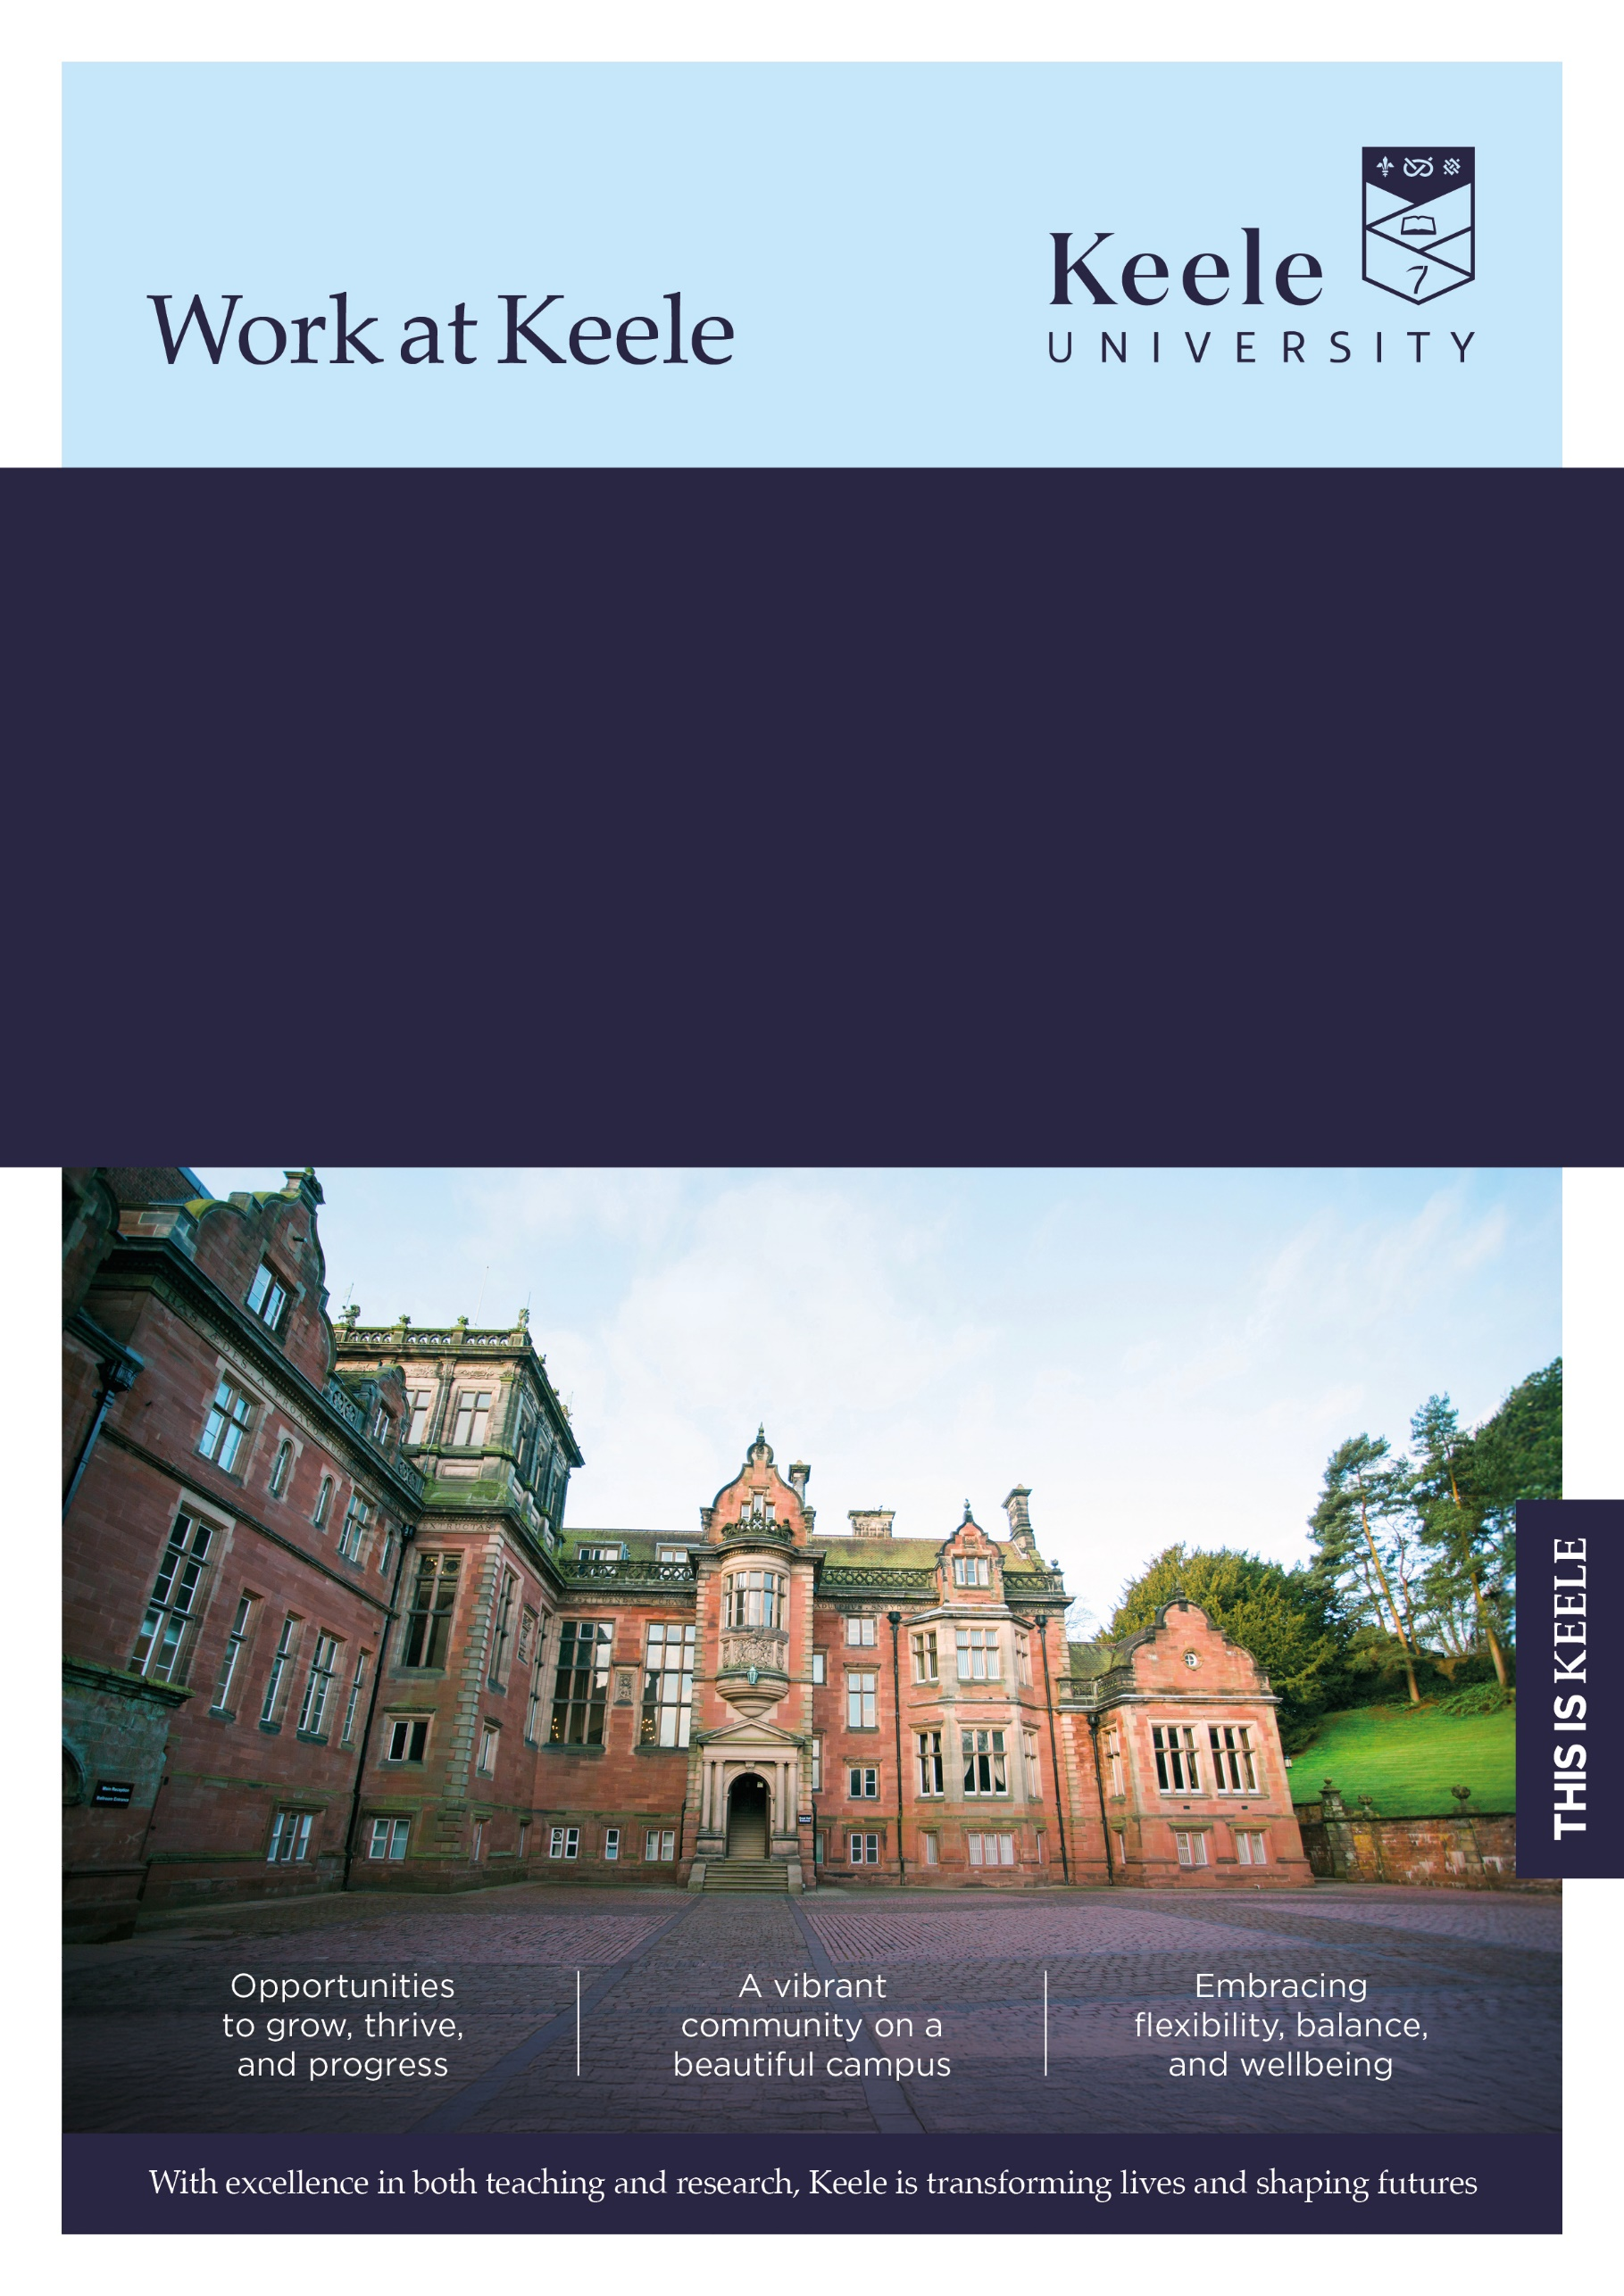

Faculty: Faculty of Natural Sciences

School: Astrophysics Research Centre

Location: Campus

Grade: 7

Salary Range: £38,249 – 46,735

Full Time FT (37.5)

Term: Fixed term until 31/06/2028

Responsible to: (Job Title) Dr Pierre Maxted (Reader in Astrophysics)

Job Ref: KU00004647

Research Associate

**Thank you for considering a role at Keele University.**

Inside this document, you'll discover key details about the job and our diverse and vibrant institution. We invite you to explore the impressive benefits that come with joining our community - [click here to learn more about our values and what makes Keele a fantastic place to work](https://www.keele.ac.uk/about/jobvacancies/).

**The Role**

The post holder will work with Dr Pierre Maxted and colleagues within the Astrophysics Research Centre at Keele University, as part of an STFC-funded project to use advanced data analysis techniques to generate high-quality data for benchmark stars in eclipsing binary systems, and to use these data to calibrate stellar models that will be needed to accurately characterize planetary systems discovered by European Space Agency PLATO mission.

**Main duties and responsibilities**

**Main duties and responsibilities**

* Plan and carry out day-to-day research activities independently using a variety of techniques within the framework of the agreed programme contributing to knowledge that supports Keele’s and the broader academic research community
* Develop research objectives and proposals for own and joint research.
* Develop new research methods and extend the research portfolio.
* Identify new areas of research and potential funding sources.
* Conduct individual and collaborative research using new techniques and methods as appropriate.
* Prepare, setup and conduct experiments using creativity to analyse and interpret data drawing conclusions and recording the outcomes.
* Conduct literature reviews.
* Analyse and interpret results/data of own research and generate original ideas based on outcomes.
* Write up results of research findings and produce work for publication in appropriate journals.
* Coordinate, attend and contribute to relevant research meetings.
* Prepare papers for stakeholder/steering groups and other bodies.
* Present information on research progress and outcomes to bodies supervising research, e.g. steering groups.
* Assist in the development of student research skills.
* Transfer knowledge from research to support course content.

#### Team Work

* Participate as a member of the research team, including contributing to decisions affecting the work of the team and dealing with problems which may affect the achievement of research objectives and deadlines.

#### Communication

* Attend and contribute to project team meetings.
* Communicate effectively across a wide range of audiences.
* Liaise, establish and maintain positive links with external agencies and providers.

**Supervision / Staffing**

* Assist with the supervision of student projects at undergraduate and postgraduate level as required.
* Provide technical assistance and supervision to members of the research team as required

This job description is not intended as an exhaustive list of duties or a restrictive definition of the post but rather should be read as a guide to the main priorities and typical areas of activity of the post-holder. These activities are subject to amendment over time as priorities and requirements evolve and as such it may be amended at any time by the line manager following discussion with the post holder.

**In addition, University staff are expected to:**

**University Policies & Procedures**

Adhere to regulations and procedures relating to data protection and information security.

Co-operate with the University in ensuring as far as is necessary, that Statutory Requirement, Codes of Practice, University Policies and Procedures at both University and Departmental level are complied with.

Adhere to the University’s environmental policy and procedures and seek to promote environmental sustainability within area of responsibility.

Ensure robust procedures and processes are followed for services and products that are procured and undertaken in line with prevailing legislation, statutory obligations and policies.

**Equality, Diversity, Health and Safety and Strategy**

Hold a duty and commitment to the principles and practice of equality and diversity and comply with the University’s Dignity and Respect Framework. Duties must be carried out in accordance with relevant Equality and Diversity legislation and University policies/ procedures / strategy.

Take reasonable care of the Health and Safety of yourself and that of any other person who may be affected by your acts or omissions at work.

**Personal Development / Performance**

Demonstrate commitment to continuing Personal/Professional Development and to engage with appropriate development activities.

Embody and uphold the University’s Vision and Values. Further information regarding the University’s Values and Behaviours Framework can be found on the Staff Intranet.

**The Person**

|  |  |  |
| --- | --- | --- |
| **Selection Criteria** | **Essential (E) or**  **Desirable (D)** | **Evidenced by:**  **Application (A)**  **Interview (I)**  **Test (T)**  **Presentation (P)** |
|  | | |
| **Qualifications / Training** | | |
| PhD in relevant subject | E | A |
| **Experience** | | |
| Experience of working in a research environment | E | A,I |
| Experience of working with specialist techniques, equipment, materials (astropy and emcee software packages, or similar) | E | A, I |
| Experience of working and communicating effectively with people from a broad range of backgrounds | E | A,I |
| Experience of writing research reports and producing publications | E | A,I |
| Experience of collecting and analysing complex research data | E | A,I |
| Experience of identifying new areas of research and sourcing potential funding | D | A,I |
| Experience of transferring knowledge to support future course content | D | A,I |
| Experience of writing grant applications | D | A,I |
| **Skills / Aptitudes / Competences** | | |
| Specialist knowledge of research methods and techniques in the research area | E | A,I |
| Ability to produce reports to strict deadlines and manage the research project | E | A,I |
| Excellent attention to detail | E | A,I |
| Excellent IT skills | E | A,I |
| Ability to build relationships and internal networks for the exchange of information and future collaboration | E | A,I |
| Excellent interpersonal and communication skills with the ability to communicate complex information both orally and in writing | E | A,I |
| **Other** | | |
| Ability to collaborate with academic colleagues and external stakeholders on areas of shared research | E | A,I |
| Committed to the application of the principles of research governance & ethics | E | A,I |
| Ability to travel internationally and undertake trips requiring overnight stays (e.g., for conferences or telescope observing runs). | E | A, I |

**Further Information**

Closing date for applications: 7th July 2025

Interviews will be held on: 22nd July 2025

**How to apply**

For full post details and to apply, please visit: [www.keele.ac.uk/jobs](http://www.keele.ac.uk/jobs).

Keele University employees wishing to apply for this vacancy should login to Employee Self Service and click on the 'View current vacancies' link.

**Eligibility to work**

This post may meet the relevant criteria to allow the University to issue a Certificate of Sponsorship to individuals who wish to come to work in the UK through the Skilled Worker Route of the UK Immigration System. For information on the sponsorship system, please visit the UK Visas and Immigration website at https://www.gov.uk/government/organisations/uk-visas-and-immigration. You are advised to assess your circumstances against the criteria set out in the UKVI policy guidance, available at https://www.gov.uk/browse/visas-immigration. UK ENIC provides advice and guidance on international qualifications at UK ENIC Visas and Nationality

**References**

You will be asked to supply details by three individuals, that can provide relevant and credible insights into your employment details and suitability for the role. This will include a reference from your current line manager (or most recent line manager if currently unemployed), and your next most recent employer (where applicable). In providing these details you are giving the University permission to request personal information about you from your referees, which may include confirmation of your previous salary, disciplinary and work history.

For graduates or candidates with limited work experience, references may be provided by individuals who can speak to your achievements and skills in other areas such as academia, volunteering or extracurricular activities.

With your consent, the University may request additional references if it is felt these are necessary to provide a more comprehensive understanding of your suitability for the role.

Further information regarding references can be found here: [www.keele.ac.uk/jobs/vacanciesfaqs](http://www.keele.ac.uk/jobs/vacanciesfaqs)

**Disability Confident**

Keele University is committed to taking positive steps to employ, keep and develop the abilities of disabled staff and has been awarded the disability symbol. We undertake to offer all applicants with a disability and who meet the minimum essential criteria an interview. If you wish to be considered under this scheme, please indicate this by selecting ‘Yes’ in the Guaranteed Interview Scheme Section of your application. You can also provide specific information of any requirements / adjustments you may require to assist you during the recruitment process within this section. For advice or guidance please contact the Recruitment Team email: [vacancies@keele.ac.uk](mailto:vacancies@keele.ac.uk).

The information you provide on your application will be forwarded to the recruiting area so that they may consider whether they can facilitate your requested adjustments. Please note that if you do not indicate that you wish to be considered under the Disability Confident scheme in your application, you will not be considered under this Scheme.

**Alternative formats**

If you have any other requirements that will help you access the application or interview process, or require documents in alternative formats, please contact [vacancies@keele.ac.uk](mailto:vacancies@keele.ac.uk).

**About Keele**

We're Keele and we're different. Founded 75 years ago to meet the demands of a new kind of society, economy and world, our principles resonate now more than ever.

We are a campus university with **over 12,500 students**, nestled in 600 acres of Staffordshire countryside and just an hour from Manchester and Birmingham. It's a big campus but a small and cosmopolitan community, with space to think and plenty to do.

Our research seeks to **improve lives and address the most pressing challenges** across our region, country, and world. Our academics are actively studying matters of global importance: from food security, climate change and smart energy, to neglected tropical diseases, global health and sustainable futures.

As well as **world-leading research** (Research Excellence Framework, 2021), Keele also sets the gold standard for teaching, with some of the most satisfied students in the country – in 2022, students ranked us **“Britain’s best university”** in the Student Crowd University Awards, and in 2023 we were awarded the **highest rating of “Gold” overall** in the Teaching Excellence Framework.

For more information about the benefits of working at Keele University, visit [www.keele.ac.uk/jobs](http://www.keele.ac.uk/jobs).

